

**Курс: «**Теория баз данных (QA)»

Тема: SELECT, INSERT, UPDATE, DELETE.

Каждый запрос из лекции «SC_DT_urok_03 Запросы SELECT, INSERT, UPDATE, DELETE» изменить в соответствии с таблицей из ДЗ1 (которую вы делали самостоятельно)

Пример:

Select PetName From Pet

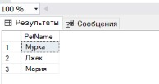

1

SELECT name, surname, position

FROM teachers;

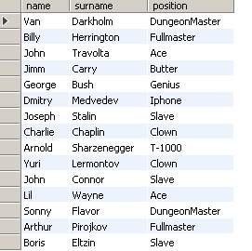

2

SELECT Name, Surname AS FullName, Employmentdate

FROM teachers;

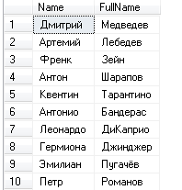

Некоторые вещи у меня не работают ….

3

SELECT Name, surname AS FullName,

Salary*1.2 AS 'Plus 20 persent'

FROM Teachers;

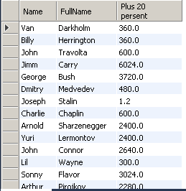

4

SELECT DISTINCT Name

FROM TEACHERS;

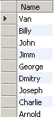

5

SELECT Name, surname, salary

FROM TEACHERS

WHERE salary > 1000;

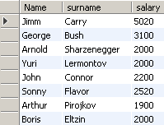

6

SELECT Name, surname

FROM TEACHERS

WHERE length(name) > 4; / WHERE length(name) !> 4 – не работает

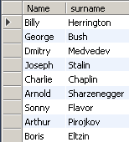

7

SELECT Name, surname, Employmentdate

FROM TEACHERS

WHERE month(Employmentdate) >=9 AND month(Employmentdate) <=11;

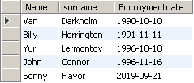

8

SELECT Name, surname, Employmentdate

FROM TEACHERS

WHERE year(Employmentdate) % 2 = 0 OR DAY(Employmentdate) % 2 <> 0;

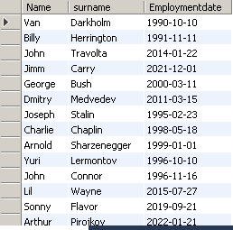

9

SELECT Name, surname, Employmentdate

FROM TEACHERS

WHERE salary IS NULL;



10

SELECT Id, Name, surname, Employmentdate

FROM TEACHERS

WHERE NOT NAME = 'Billy';

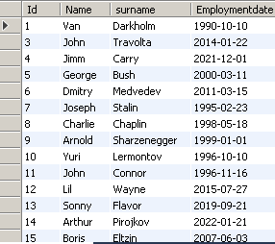

11

SELECT Id, Name, surname, Employmentdate, salary, premium

FROM TEACHERS

WHERE premium is not null;

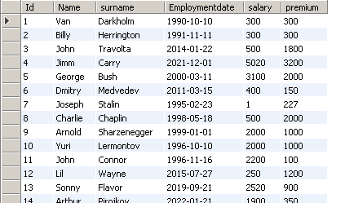

1.4. Предложение ORDER BY

12

SELECT Id, Name, surname, Employmentdate

FROM TEACHERS

ORDER BY Employmentdate;

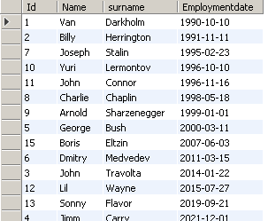

13

SELECT Id, Name, surname, Employmentdate

FROM TEACHERS

ORDER BY name DESC, surname ASC;

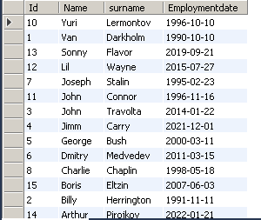

Ключевые слова IN, BETWEEN, LIKE

14

SELECT Id, Name, surname, Employmentdate, Salary, Premium

FROM TEACHERS

WHERE name = 'Billy' OR surname = 'Eltzin'

OR surname = 'Stalin';

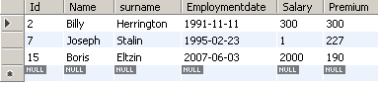

15

SELECT Id, Name, surname, Employmentdate, Salary, Premium

FROM TEACHERS

WHERE surname IN ('Billy', 'Stalin', 'Eltzin');

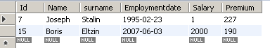

16

SELECT Id, Name, surname, Employmentdate, Salary, Premium

FROM TEACHERS

WHERE Employmentdate <= '2010-01-01'

AND Employmentdate >= '2000-12-31';



17

SELECT Id, Name, surname, Employmentdate, Salary, Premium

FROM TEACHERS

WHERE Employmentdate BETWEEN '2000-01-01' AND '2020-12-31';

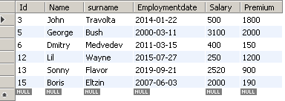

18

SELECT Id, Name, surname, Employmentdate

FROM TEACHERS

WHERE surname NOT BETWEEN 'E' AND 'G';

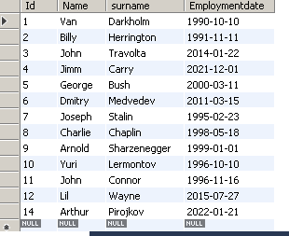

19

SELECT Id, Name, surname, Employmentdate

FROM TEACHERS

WHERE Name LIKE 'B%' AND surName LIKE '%n'; 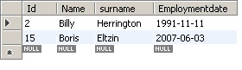

20

SELECT Name AS Имя, Surname AS Фамилия

FROM teachers

ORDER BY Name

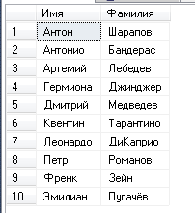

21

SELECT Name, Surname

FROM Students

WHERE Name='Низар' OR Surname = 'Аманов'

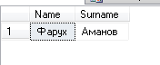

22

SELECT Name, Surname

FROM Students

WHERE Name IN ('Антон', 'Захар')

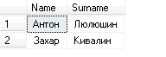

23

INSERT INTO Students(Name, Surname,GroupId)

VALUES ('Антон','Сергеев',2),

('Антонин','Сергееввский',3)



24

INSERT INTO Temp(Name,Salary,Surname)

SELECT Name,Salary,Surname

FROM Teachers



25

SELECT Name,Salary,Surname

INTO TEMP2

FROM Teachers



26

UPDATE Temp

SET Name = 'Франкенштейн'

WHERE id = 3



27

DELETE FROM Temp

WHERE Name = 'Франкенштейн'

